CSI3007 – Advanced Python Programming
Lab Activity 6 (01-08-2025)
NAME : Shriharsh S Kotecha
REG NO : 22MIC0021
Python Dictionary Quiz
Team Quiz:
Participants:
Sonali R
Madayanthikaa R
Harshini Supriya J
Shriharsh S Kotecha
Sushank S N
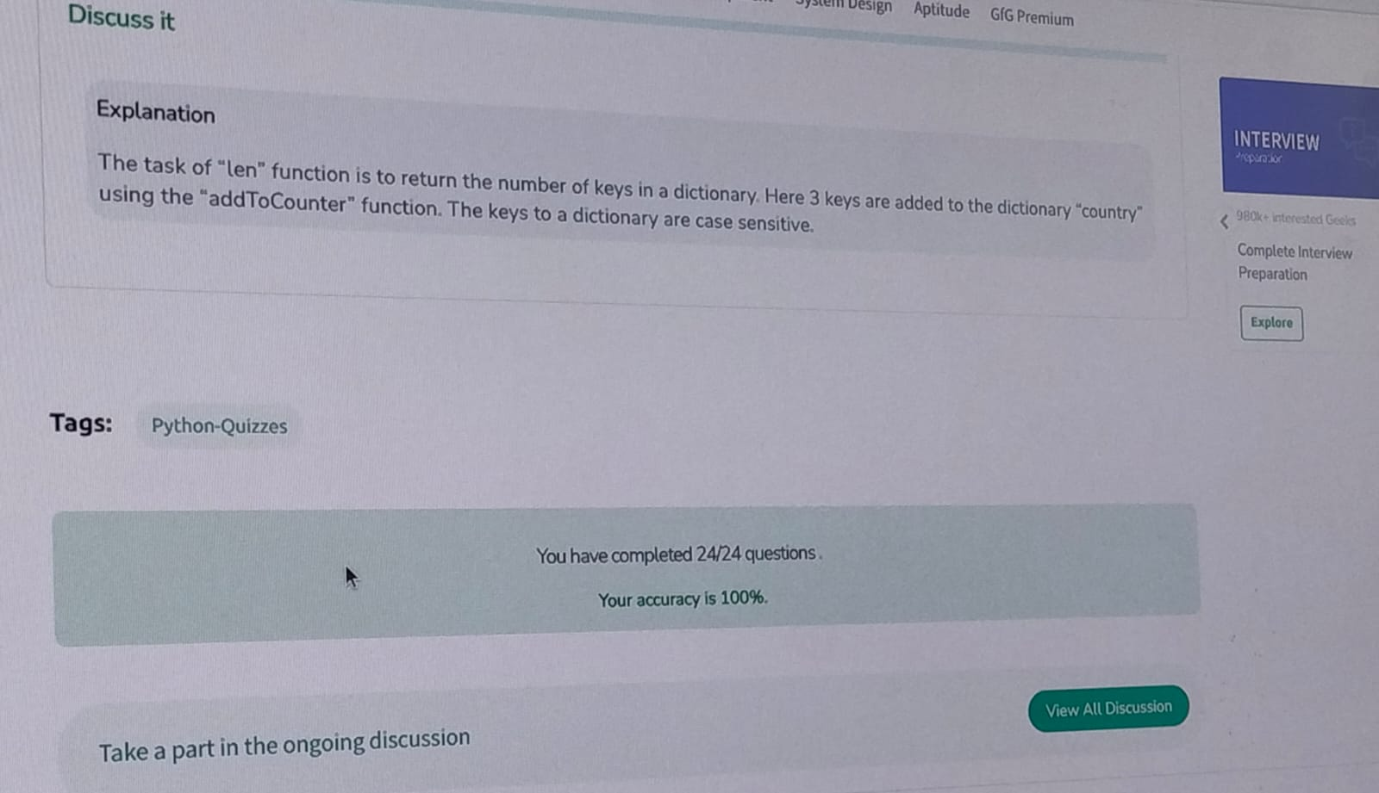
Answered in LAB:
Which method can be used to safely add a new key-value pair without overwriting existing keys?
A) dict.get()
✅ B) dict.setdefault()
C) dict.pop()
D) dict.update()

